**Name : Shahzadi Begum Shaikh Rafique**

**Subject : SQL Assignment**

1. Design the above database with following table by applying Primary key and foreign key

Customer Table :

Create Table Customer

(

CustomerId int PRIMARY KEY,

FirstName nvarchar (40),

LastName nvarchar(40),

City nvarchar(40),

Country nvarchar(40),

Phone nvarchar(20)

);

CREATE INDEX CustomerName

ON Customer(FirstName,LastName);

Order Table :

Create Table [Order]

(

OrderId int PRIMARY KEY,

OrderDate datetime,

OrderNumber nvarchar(10),

CutomerId int FOREIGN KEY REFERENCES Customer(CustomerId),

TotalAmount decimal(12,2)

);

CREATE INDEX OrderCustomerId

ON [Order](OrderId);

CREATE INDEX OrderOrderDate

ON [Order](OrderDate);

Order Item Table :

Create Table OrderItem

(

ItemId int PRIMARY KEY,

OrderId int FOREIGN KEY REFERENCES [Order](orderId),

ProductId int FOREIGN KEY REFERENCES Product(ProductId),

UnitPrice decimal(12,2),

Quantity int,

);

CREATE INDEX OrdeItemOrderId

ON OrderItem(OrderId);

CREATE INDEX OrderItemProductId

ON OrderItem(ProductId);

Product Table :

Create Table Product

(

ProductId int PRIMARY KEY,

ProductName nvarchar(50),

UnitPrice decimal(12,2),

Package nvarchar(30),

IsDiscontinued bit

);

CREATE INDEX ProductSupplierId

ON Product (ProductId);

CREATE INDEX ProductName

ON Product (ProductName);

1. Insert Records in all tables

Customer Table :

INSERT INTO Customer (CustomerId,FirstName,LastName,City,Country,Phone)

VALUES('111','Shahzadi','Inamdar','Aurangabad','India','0123456789'),

('222','Shazli','Shaikh','Mumbai','India','0123456888'),

('333','Safa','Shaikh','XYZ','US','0123456777'),

('444','Rehan','Khan','Riyadh','UAE','0123456555'),

('555','Arish','Siddiqui','Beed','India','0123456444');

('2022','Subhan','Mohammed','Aagra','Germany','189456327');

Order Table :

INSERT INTO [Order] (OrderId,OrderDate,OrderNumber,TotalAmount)

VALUES('121212','2018-06-02 10:45:09 AM','2345','3335'),

('131313','2019-05-26 07:33:33 PM','5432','4999'),

('141414','2020-08-18 12:56:59 AM','12195','2688'),

('151515','2021-03-23 09:11:19 PM','56942','5200'),

('161616','2022-02-07 05:17:16 AM','08642','2500');

Order Item Table :

INSERT INTO OrderItem(ItemId,UnitPrice,Quantity)

VALUES('100','1000','15'),

('80','2555','10'),

('29','299','12'),

('229','1700','20'),

('250','500','50');

Product Table :

INSERT INTOProduct(ProductId,ProductName,UnitPrice,Package,IsDiscontinued)

VALUES('3001','ABC','20','100','True'),

('5123','XYZ','9','120','True'),

('6123','ASAS','18','23','True'),

('9455','OPQ','11','55','True'),

('1282','LMN','16','32','True');

1. In Customer table First Name Attribute should not accept null value

ALTER TABLE Customer

ALTER COLUMN [FirstName] nvarchar(40) NOT NULL

UPDATE Customer SET [FirstName]='' WHERE [FirstName] IS NULL

1. In Order table Order Date should not accept null value

Alter Table [Order]

ALTER COLUMN [OrderDate] datetime NOT NULL;

1. Display all customer details

Select * From Customer

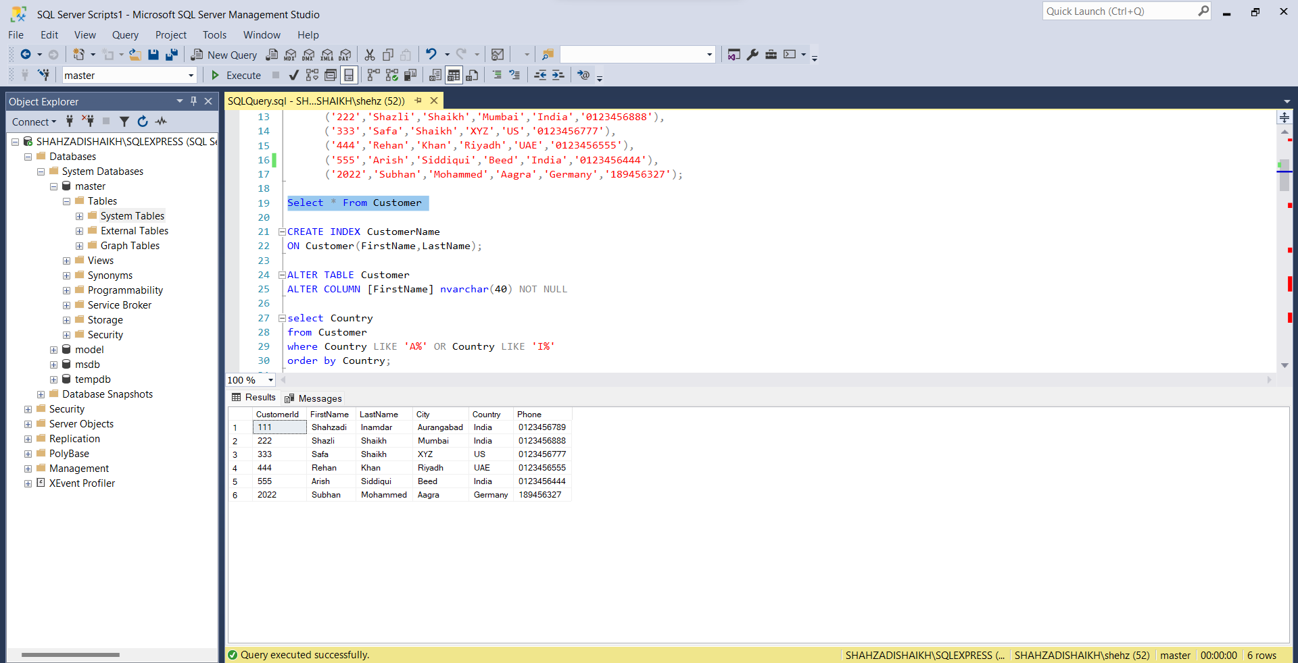

1. write a query to display Country whose name starts with A or I

select Country

from Customer

where Country LIKE 'A%' OR Country LIKE 'I%'

order by Country;

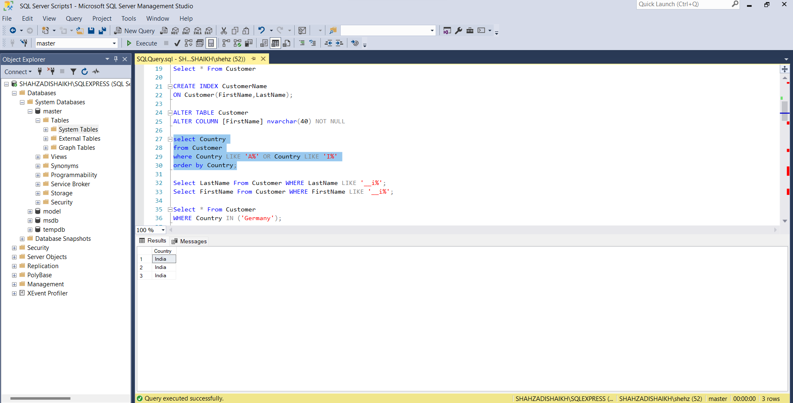

1. write a query to display whose name of customer whose third character is i

Select FirstName From Customer WHERE FirstName LIKE '__i%';

Select LastName From Customer WHERE LastName LIKE '__i%';

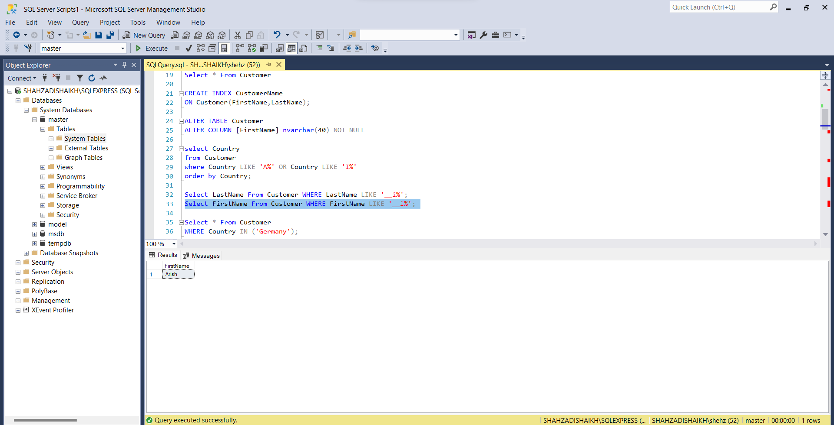

1. Display the details from Customer table who is from country Germany

Select * From Customer

WHERE Country = 'Germany';

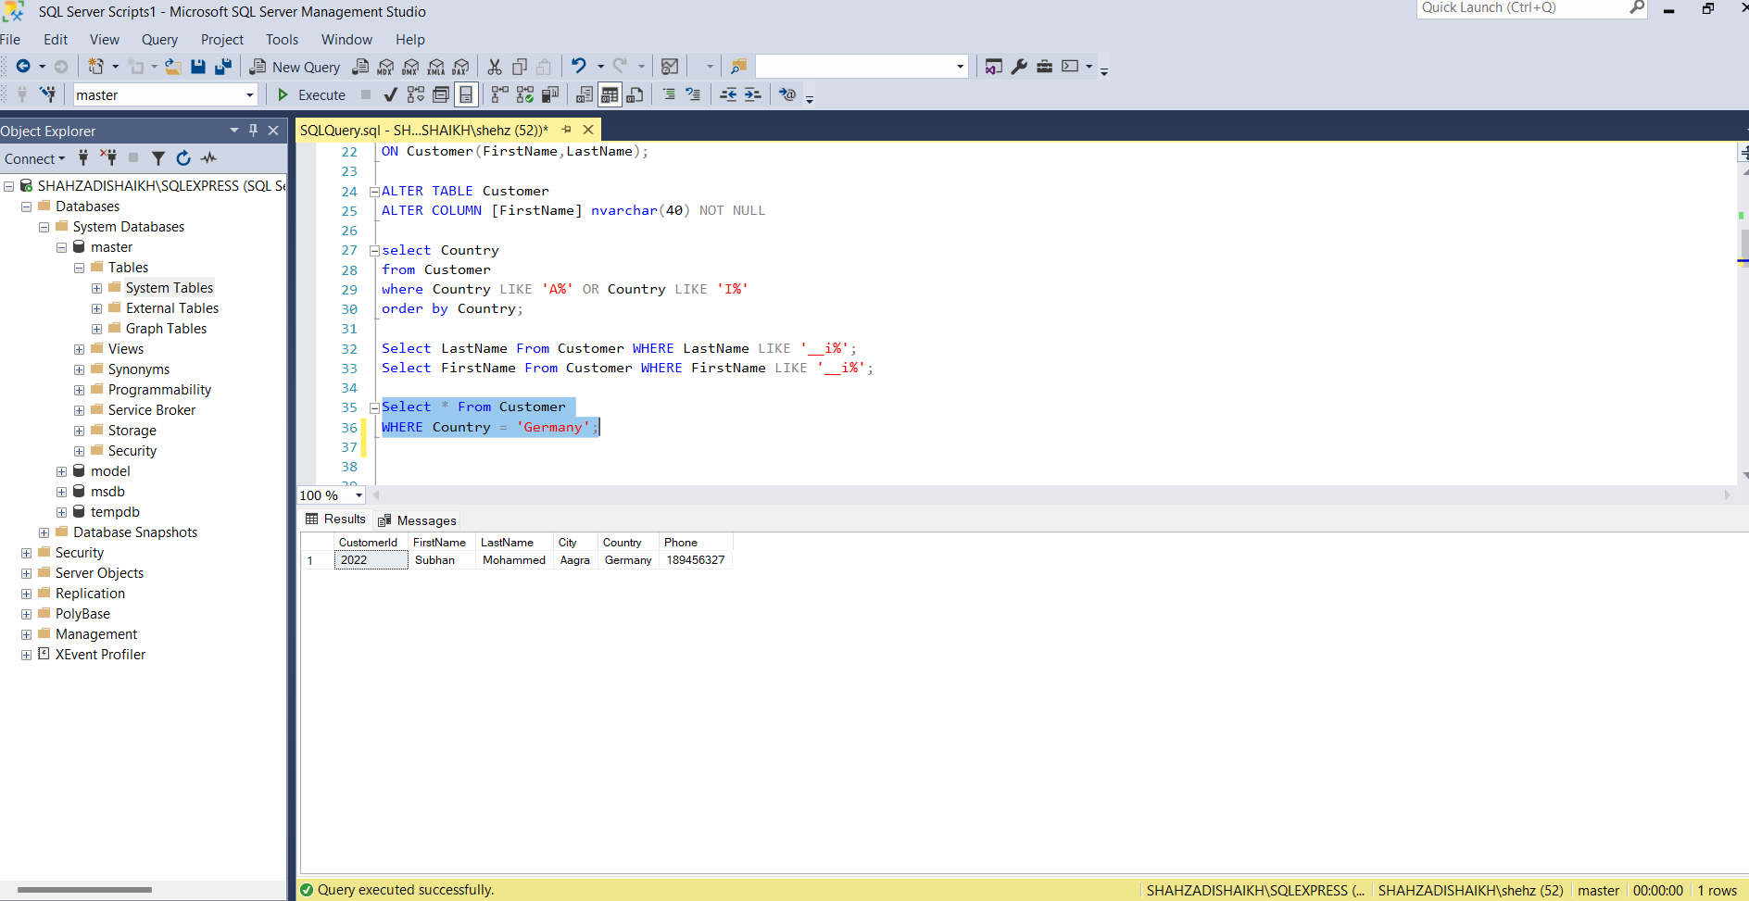

1. Display the full name of the employee

Select FirstName +' '+ LastName

AS Employee_name

FROM Employee;

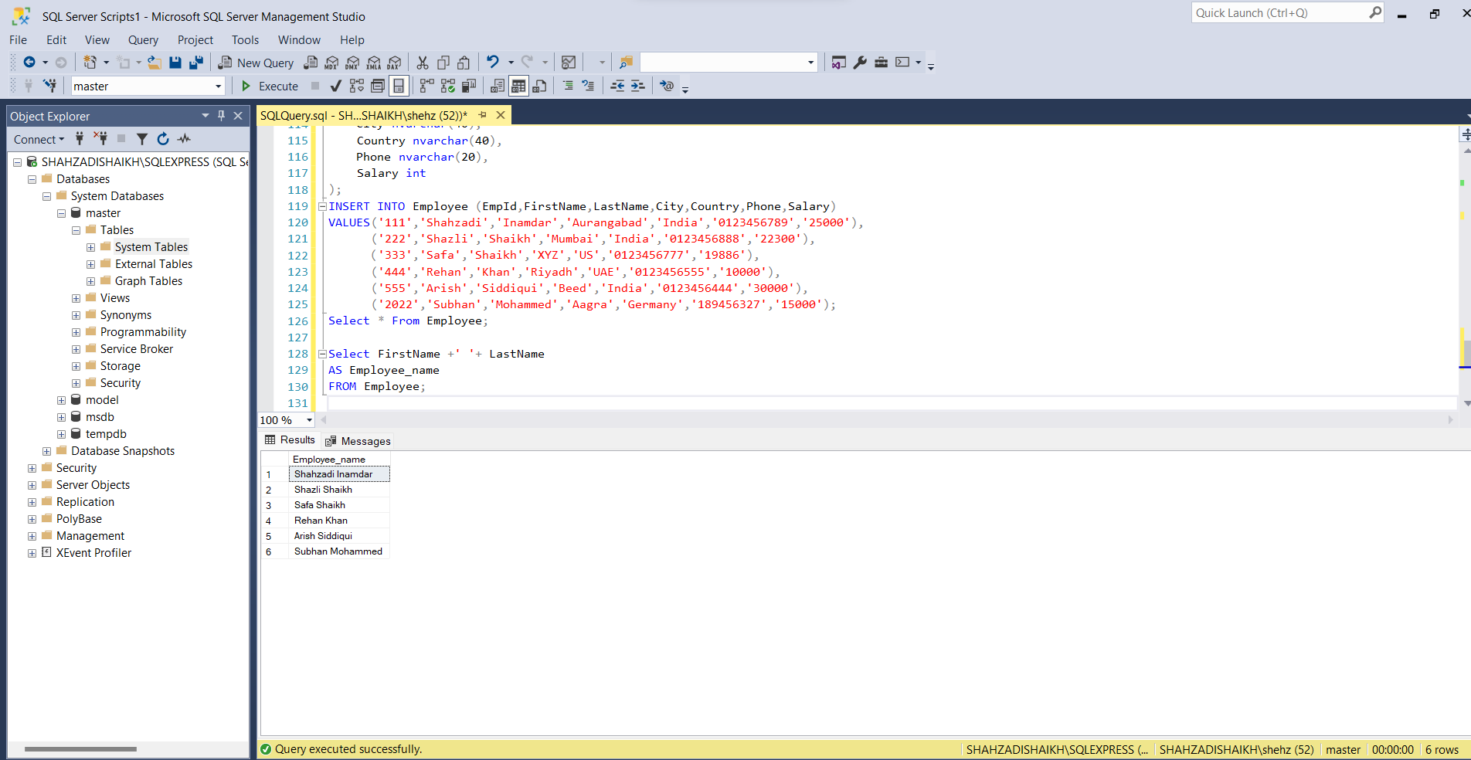

1. Display the customer details who has Fax number

select FaxNumber

From Customer;

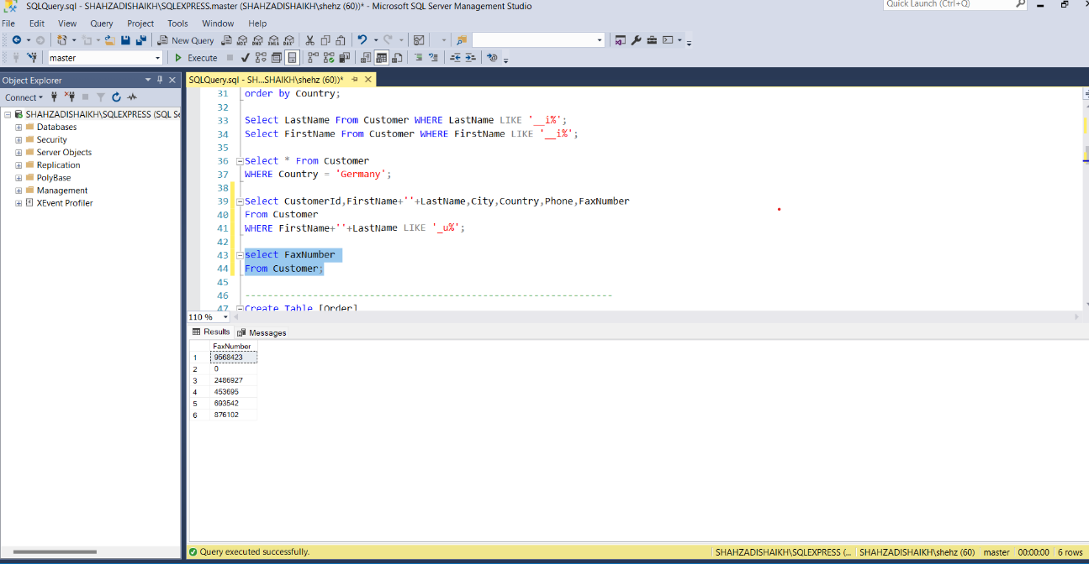

1. display the customer details whoes name holds second letter as U

Select CustomerId,FirstName+''+LastName,City,Country,Phone,FaxNumber

From Customer

WHERE FirstName+''+LastName LIKE '_u%';

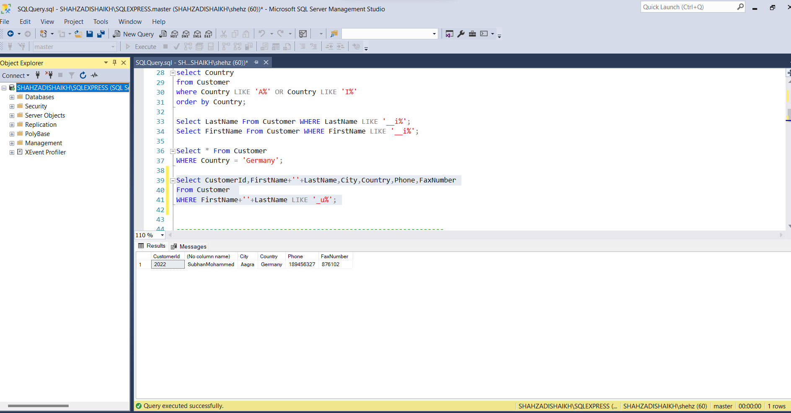

1. select order Details where unit price is greater than 10 and less than 20

SELECT UnitPrice

FROM Product

WHERE UnitPrice >10

And UnitPrice <20

ORDER BY ProductId;

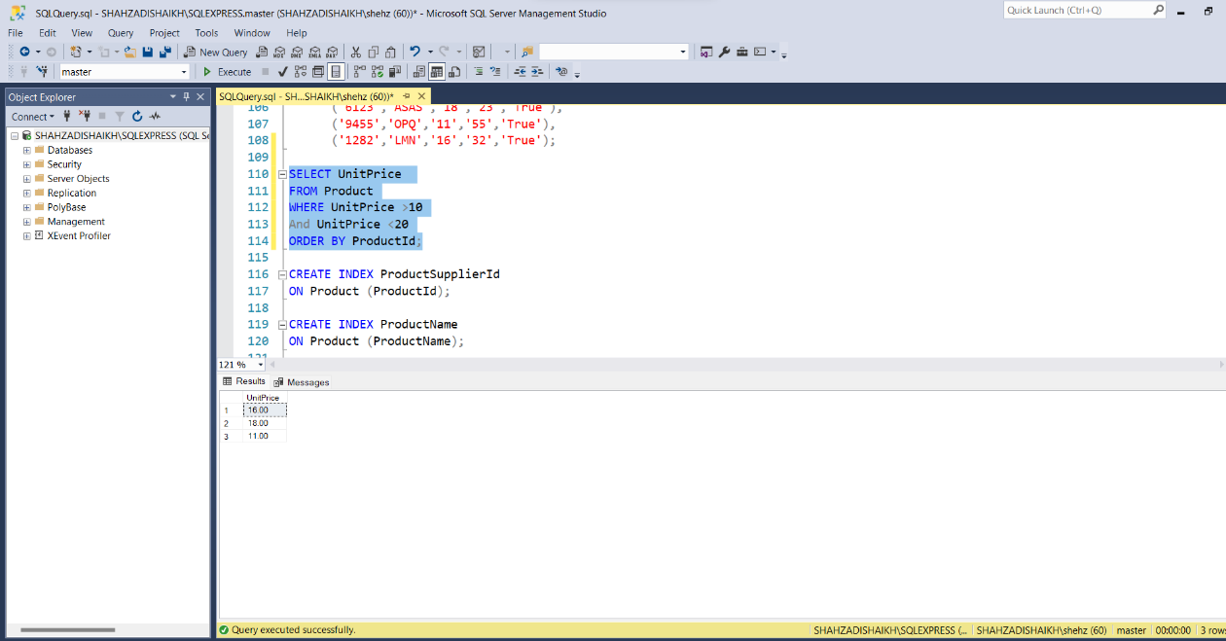

1. Display order details which contains shipping date and arrange the order by date

Select Shipping

As Shipping_Date

From [Order]

Order By OrderDate;

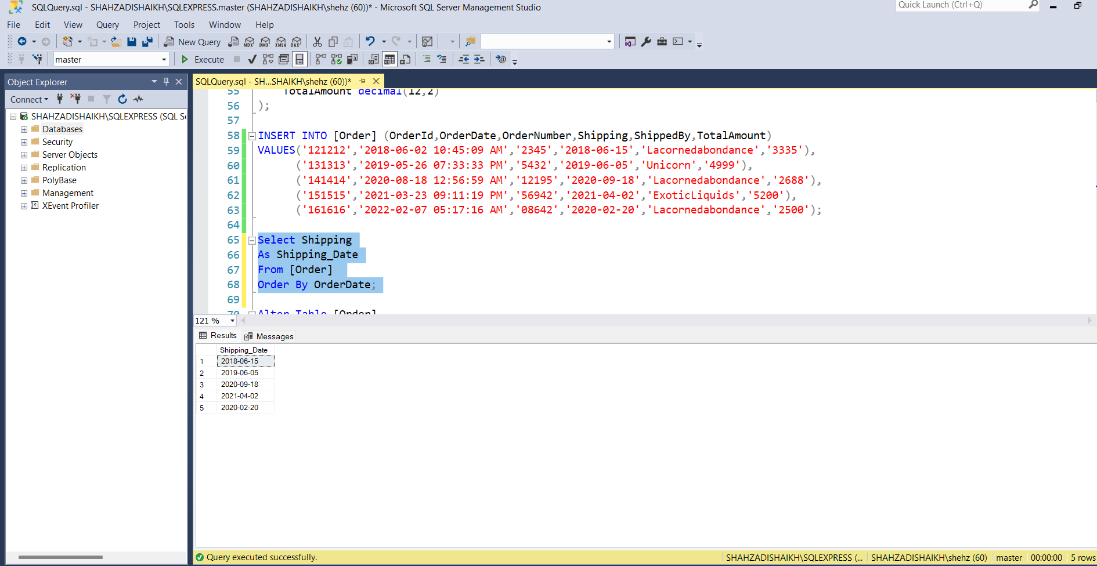

1. Print the orders shipped by ship name 'Lacorne d'abondance' between 2 dates (Choose dates of your choice)

Select Shipping,ShippedBy

from [Order]

Where ShippedBy = 'Lacornedabondance'

Between '2017-02-20' And '2021-06-20';

1. Print the products supplied by 'Exotic Liquids'

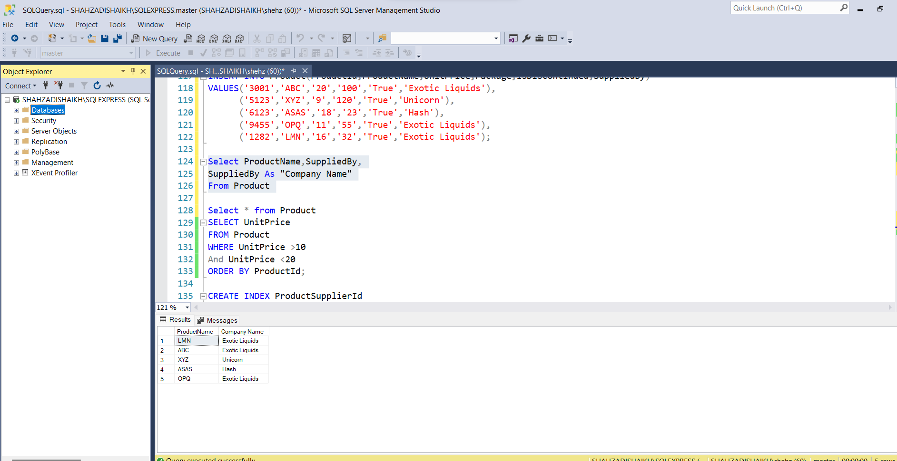

1. print the average quantity ordered for every product

SELECT ProductName,UnitPrice,Package

FROM Product

WHERE UnitPrice > (SELECT avg(UnitPrice) FROM Product)

ORDER BY UnitPrice;

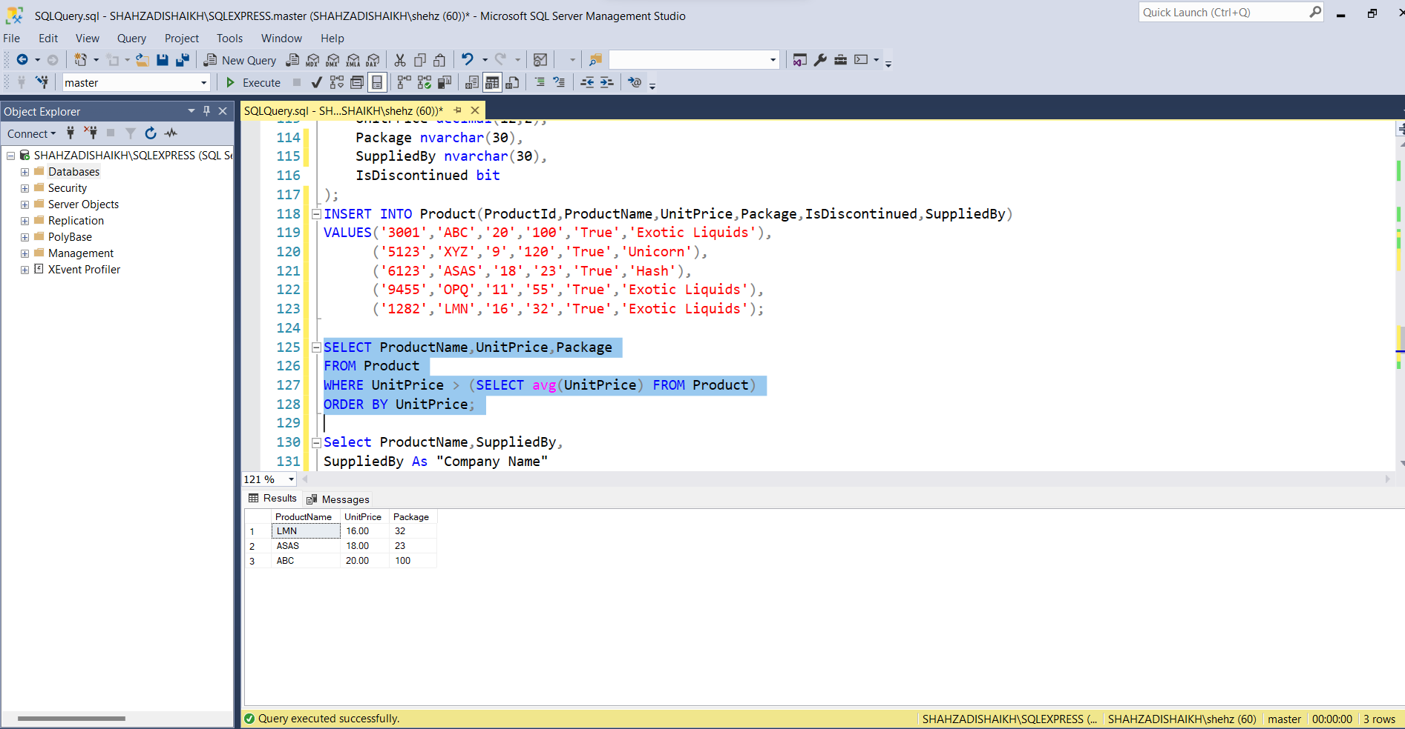

1. Print all the Shipping company name and the ship names if they are operational

SELECT ShipName,ShippingCompName

FROM [Order]

WHERE Discontinued = "False"

ORDER BY ShipName;

1. Print all Employees with Manager Name

Select e.employee_id 'Emp_Id', e.last_name 'Employee',

m.employee_id 'Mgr_Id', m.last_name 'Manager'

FROM employees e

join employees m

ON (e.manager_id = m.employee_id);

1. Print the bill for a given order id bill should contain Product name, Category name, price after discount.

Select ProductId,ProductName,UnitPrice

FROM Product

WHERE UnitPrice >= 40

ORDER BY ProductId;

1. Print the Total price of orders which have the products supplied by 'Exotic Liquids' if the price is > 50 and also print it by Shipping company's Name

Select OrderId,SuppliedBy,(TotalAmount-Price)/Price*100 As Discount

FROM [Order]

WHERE SuppliedBy= ‘Exotic Liquids’ And TotalAmount >=50

ORDER BY OrderId;